Virtual Network Setup

🎯 Objective
Understand how data moves between devices in a small network and learn how to configure IP addressing and routing.

🗺️ Network Topology
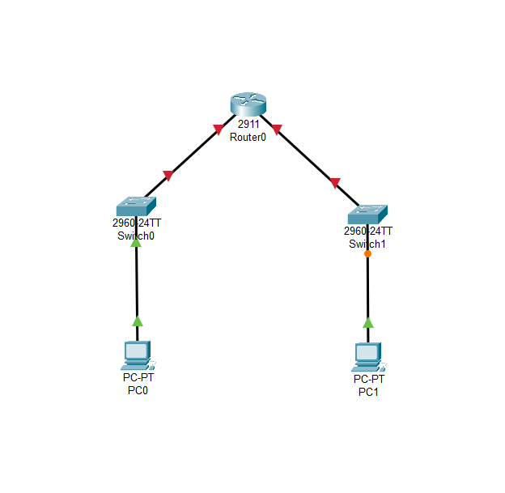

⚙️ Tools and Technologies Used
Category | Packet Tracer v 8.2.2.0400
Simulation | Packet Tracer

🧱 Network Design

🔸 IP Addressing Plan
Device | Interface | IP Address | Subnet Mask | Description
PC0 | NIC | 192.168.10.10 | 255.255.255.0 | LAN A
Router0 | G0/0 | 192.168.10.1 | 255.255.255.0 | Gateway for LAN A
Router0 | G0/1 | 192.168.20.1 | 255.255.255.0 | Gateway for LAN B
PC1 | NIC | 192.168.20.10 | 255.255.255.0 | LAN B

🔸 🔧 Configuration Steps
Configuration of Router0 using CLI
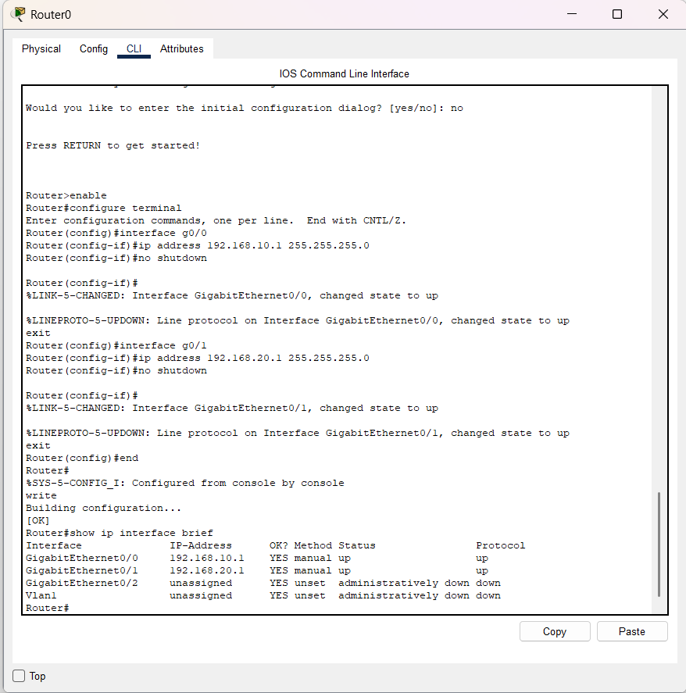
PC0 configuration
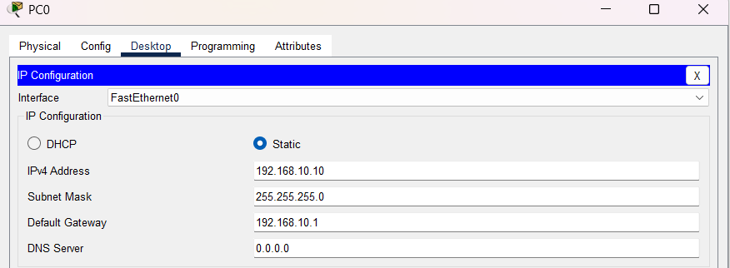
PC1 configuration
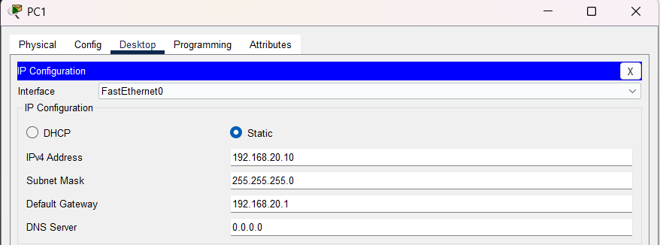

🔍 Testing and Verification
Ping test on PC0
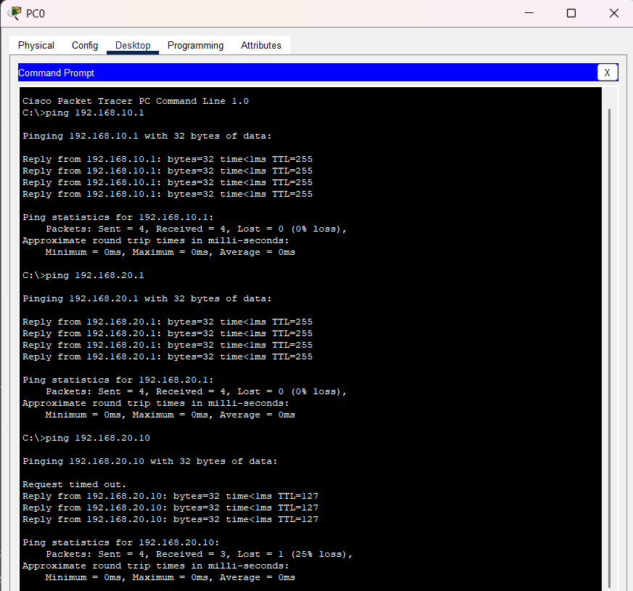
Ping test on PC1
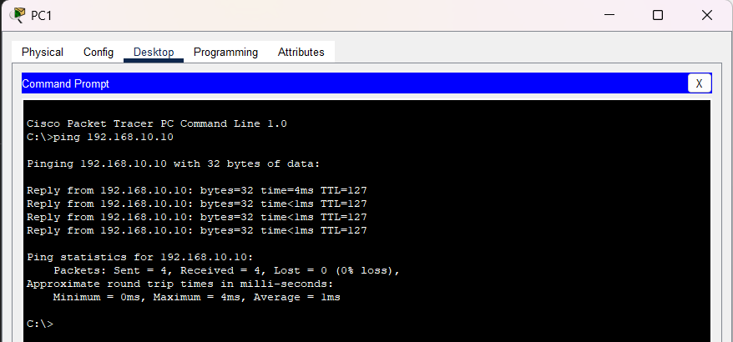

🧠 Lessons Learned
- I learned that a router is needed to communicate between different network.
- I learned how to configure a router using CLI command.
- I learned that a gateway is the IP address of the router that a network will use when it needs to communicate with a device outside of the network.

